### 

## 7. Public Course User Site

### a. Class Diagram

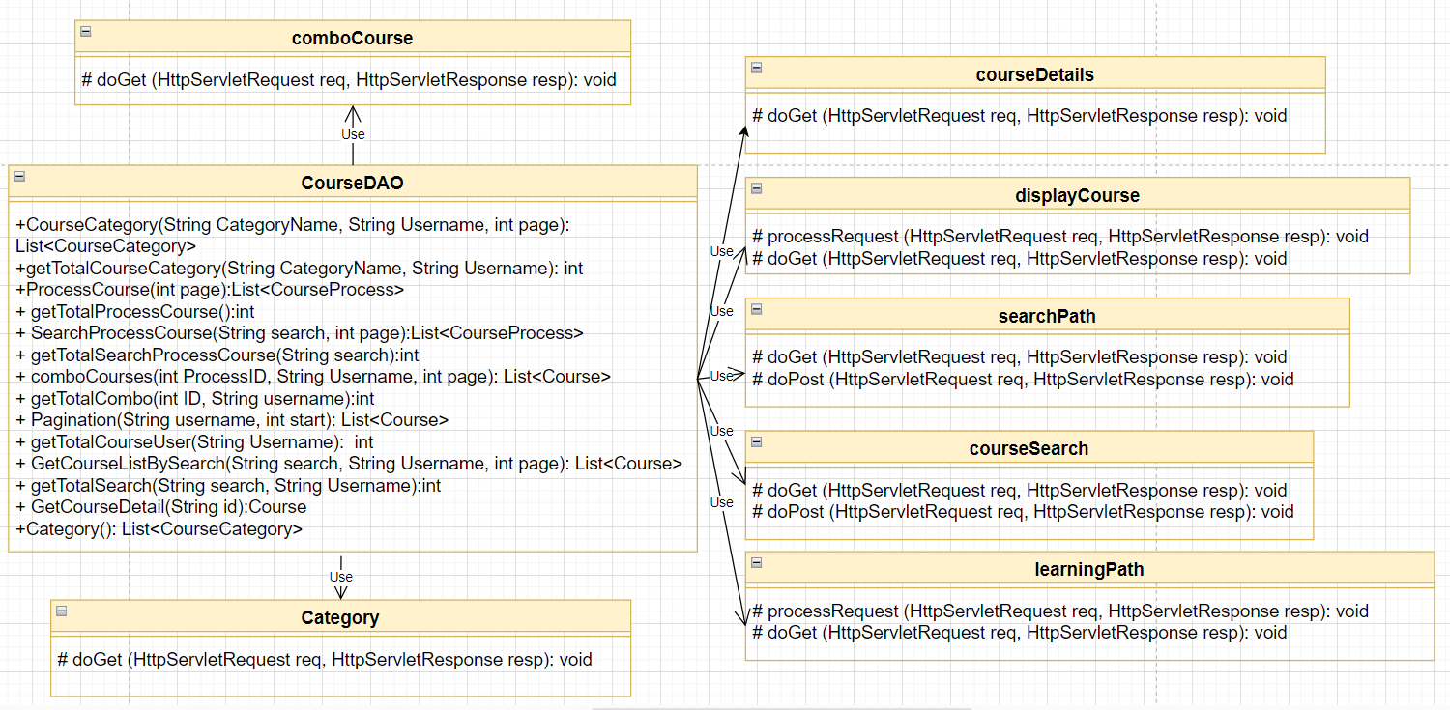

### b. Class Specifications

***CourseDAO.java***

|  |  |  |
| --- | --- | --- |
| **No** | **Method** | **Description** |
| 01 | public List<CourseCategory> CourseCategory(String CategoryName, String Username, int page) | Handle request display course information in category and pagination |
| 02 | public int getTotalCourseCategory(String CategoryName, String Username) | Handle request get total number of course category |
| 03 | public List<CourseProcess> ProcessCourse(int page) | Handle request display process course and pagination |
| 04 | public int getTotalProcessCourse() | Handle request get total number of process course |
| 05 | public List<CourseProcess> SearchProcessCourse(String search, int page) | Handle request find process course by name learning path and pagination |
| 06 | public int getTotalSearchProcessCourse(String search) | Handle request get total number of process course when search |
| 07 | public List<Course> comboCourses(int ProcessID, String Username, int page) | Handle request display course information in learning path and pagination |
| 08 | public int getTotalCombo(int ID, String username) | Handle request get total number of combo course in process course |
| 09 | public List<Course> Pagination(String username, int start) | Handle request display course information and pagination |
| 10 | public int getTotalCourseUser(String Username) | Handle request get the total number of courses the user has not purchased |
| 11 | public List<Course> GetCourseListBySearch(String search, String Username, int page) | Handle request find course by name course or name creator and pagination |
| 12 | public int getTotalSearch(String search, String Username) | Handle request get the total number of courses the user has not purchased when search |
| 13 | public Course GetCourseDetail(String id) | Handle request display course detail |
| 14 | public List<CourseCategory> Category() | Handle request display category |

### c. Sequence Diagram(s)

#### View course

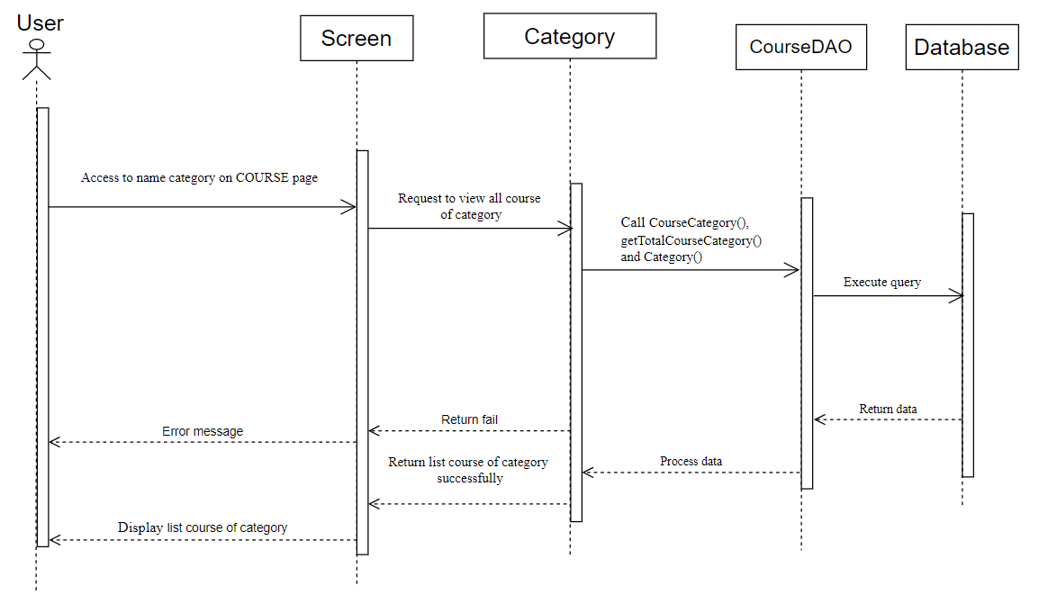

#### Search course

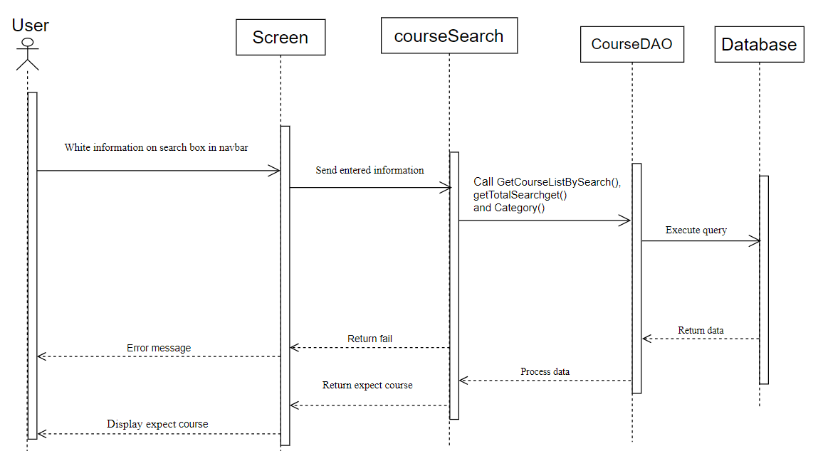

#### View category

